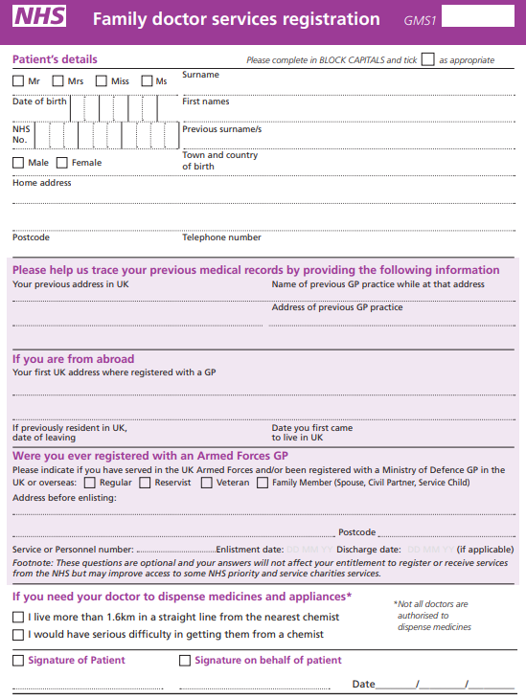

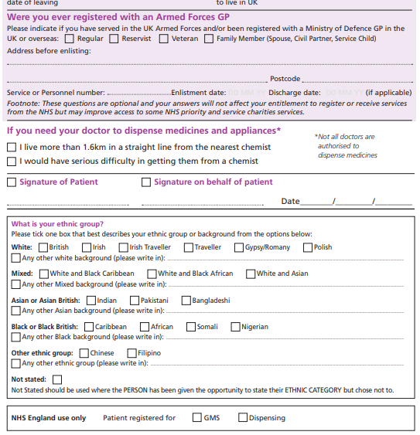

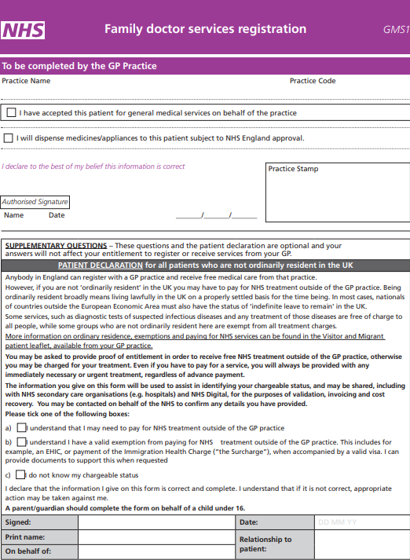

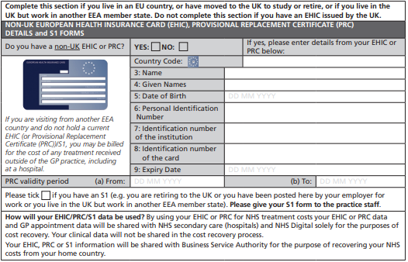

**Nominated Pharmacy……………………………………………………………………………………….**

**NORTHGATE PRACTICE NEW PATIENT QUESTIONNAIRE**

All information will be treated as confidential. We ask you to **FULLY** complete this questionnaire to ensure we have accurate details about your medical health should you require treatment prior to your records arriving from you old Doctor.

|  |  |
| --- | --- |
| **Surname** | **Address**  **Postcode** |
| **Forenames** |
| **Telephone number(s): Mobile number Email:** |
| **Date of Birth:** |
| **Place of Birth:** |
| **Occupation:** | **NHS Number:** |

Would you be happy to be contacted via email? YES / NO

Do you consent to the surgery using your mobile number to send you texts relating to your experiences at the surgery and anything else we feel may be of benefit to you as our patient? YES/NO

**PREVIOUS GP:** Please state name and address

**NEXT OF KIN:** Please state name, relationship, address and telephone /mobile number

**CARER:** If you have a carer please state name, address and telephone number

**ARE YOU A CARER: YES/NO**

**MEDICAL HISTORY:** Please list any serious illnesses, operations, accidents, disabilities

(e.g. deafness, partially sighted etc.) with dates.

**MEDICATION:** Please list the names of all medications taken (including contraceptive pill)

**ALLERGIES:** Please list all known allergies to medications (e.g. penicillin)

Height……………………………… Weight………………………………

|  |  |
| --- | --- |
| **SMOKING STATUS:** Please tick relevant box(s) (e.g.🗹) and insert quantity. | |
| I have never smoked | Cigarette smoker …… / day |
| Pipe smoker …….oz/week | Cigar smoker ……../day |
| I would / would not like help to stop smoking. (please delete as appropriate) | |
| I currently do not smoke. I stopped ……………… years ago | |

**ALCOHOL**

**This is one unit of alcohol…**

**Units of alcohol**

**…and each of these is more than one unit**

**Units of alcohol**

|  |
| --- |
| **How many units do you drink per Week ………………….** |

|  |  |  |  |
| --- | --- | --- | --- |
| **How often do you have a drink that contains alcohol?** | | | |
| 0 Never | 1 Monthly or less | 2 2- 4 times per month | 3 2-3 times per week 4 4+ time per week |

|  |  |  |  |  |
| --- | --- | --- | --- | --- |
| **How many standard alcoholic drinks do you have on a typical day when you are drinking?** | | | | |
| 0 1-2 | 1 3-4 | 2 5-6 | 3 7-8 | 4 10+ |

|  |  |  |  |  |
| --- | --- | --- | --- | --- |
| **How often do you have 6 or more standard alcoholic drinks on one occasion?** | | | | |
| 0 Never | 1 Less than monthly | 2 Monthly | 3 Weekly | 4 Daily or almost daily |

|  |  |  |  |  |
| --- | --- | --- | --- | --- |
| **EXERCISE ACTIVITY:** Moderately vigorous activity means exercise such as walking briskly  Average number of 20-minute sessions of moderately vigorous activity in one week: | | | | |
| Zero | One | Two | Three | More than three |

|  |  |
| --- | --- |
| **FAMILY HISTORY**: Please tick relevant family history under Age 60 (e.g.🗹) followed by what relation they are to you only include immediate family, Mother, Father, Brothers or Sisters | |
| High Blood Pressure ……………….. | Diabetes …………………….. |
| Heart Disease ……………….. | Glaucoma ………………………. |
| Stroke ……………… | Thrombosis (e.g. clots in calf/lung) |
| High Cholesterol ……………….. | Other Hereditary Disease - *Please specify:* |

|  |  |  |
| --- | --- | --- |
| **FOR CHILDREN ONLY:** Please tick previous vaccinations e.g.🗹 | | |
| Diphtheria/Tetanus | MMR | |
| Whooping Cough | Rubella (German Measles) | |
| Polio | Meningococcal C | |
| HiB | Travel vaccinations - *Please specify:* | |
| ***If of school age, Name of School you attend:***  *………………………………………………………………………………………………………………* | |
|  | |
| **ETHNICITY DATA:**  The government and NHS require us to collect information on patient’s ethnicity when registering with the practice. We would be most grateful if you could tick the appropriate box | |

|  |  |  |
| --- | --- | --- |
| **A:** | **White** |  |
|  | British | Irish |
|  | Any other white background (please write in)……………….. |  |

|  |  |  |
| --- | --- | --- |
| **B:** | **Mixed** |  |
|  | White and Black Caribbean | White & Black African |
|  | White and Asian |  |
|  | Any other mixed background (please write in)……………….. |  |

|  |  |  |
| --- | --- | --- |
| **C:** | **Asian or Asian British** |  |
|  | Indian | Pakistani |
|  | Bangladeshi |  |
|  | Any other Asian Background (please write in)……………….. |  |

|  |  |  |
| --- | --- | --- |
| **D:** | **Black or Black British** |  |
|  | Caribbean | African |
|  | Any other Black Background (please write in)……………….. |  |

|  |  |  |
| --- | --- | --- |
| **F:** | **Chinese or other ethnic group** |  |
|  | Chinese |  |
|  | Any other (please write in)……………….. |  |
|  | **I do not want to disclose this information.** |  |

|  |  |
| --- | --- |
| **First language: …………………………………………..** | **Do you require an interpreter? Yes**  No |

|  |  |  |
| --- | --- | --- |
| **Have you ever been in or are currently in any of the following:** | | |
| **Military Service**  **Army Service**  **Navy Service**  **Royal Air Force** | | |
|  | | |
| **If yes please specify _____________________________________**  Would you like a HIV test?Yes  No | | |
| **Patient Representative Group (PRG)** |  |  |
| Did you also know that the surgery has a Patient Representative Group (PRG)?  If you would like further information or would like to know how you can join the group, please ask at reception for further details. | | |
|  | | |
| **Patient Online services - 13+:**  From 1.4.2019 all patients will be automatically enrolled for GP Online Services. This will allow you to access a range of services via your computer, mobile or tablet. Once you have signed up, you will be able to book or cancel appointments online, renew or order repeat prescriptions online and view parts of your GP record, including information about medication, allergies.  Login details will be sent to you via the email address you have provided. If you do not wish to have access, please tick the box to opt out | | |
| **PATIENT I.D REQUIRED**  The surgery requires proof of identity in the form of Birth Certificate, Passport or Driving Licence. Also proof of address in the form of Utility Bill which must be dated within the last 3 months from date of requesting registration. Please make sure you bring these with you when returning completed forms to join the surgery. | | |
| **APPLICATION TO JOIN THE PRACTICE PROCEDURE** | | |

|  |  |  |  |  |  |  |  |  |  |  |
| --- | --- | --- | --- | --- | --- | --- | --- | --- | --- | --- |
| 1. | | | Is the patient in the practice area? | | | Yes  No | | | | |
| 2. | | | Has the patient been removed from a GP list previously? | | | Yes  No | | | | |
| 3. | | | Has the patient been removed from this practice list in the past? | | | Yes  No | | | | |
|  | | | | | | | | | | |
| 4. | | Explain the prescription policy, does the patient agree to the policy? | | | | | Yes  No | | | |
| 5. | | Explain the Female Doctor policy? | | | | | Yes  No | | | |
| 6. | | Get patient to fill in purple application form. | | | | | Yes  No | | | |
| 7. | | Has the patient put their post code? | | | | | Yes  No | | | |
| 8. | | Ensure all forms are fully completed and signed. | | | | |  | | | |
|  | |  | | | | |  | | | |
|  | |  | | | | |  | | | |
| 9. Check Ethnicity | | | | First Language | Smoking status | | | Offered Smoking Support | | |
| All other parts | | | | NHS Number or questions from GMS1 form asked | | | |  | | |
| Did the patient tick **Yes**  or **No**  to a HIV test | | | | | | | | | | |
| School  Immunisation history | | | | | | | | | | |
|  | | | | | | | | | | |
| 10. | Has the patient presented with a valid passport, birth certificate or driving license AND proof of address? | | | | | | | | | Yes  No |
| 11. | Does the patient have a chronic disease (Diabetics, COPD or Asthma) or an alcohol score of 5 or greater? | | | | | | | | | Yes  No |
| Book for relevant review with Nurse. (If Diabetic check book for bloods first)   |  |  | | --- | --- | | Date of appointment …………………………………. | With ……………………………………… | | | | | | | | | | Yes  No | |

|  |  |  |
| --- | --- | --- |
| 12. | Does the patient require any medication or do they have a problem they need to see a doctor for? | Yes  No |
|  | |  |
| 13. | Practice leaflet given? | Yes  No |
| 14. | Zero tolerance policy? | Yes  No |
|  |  |  |

|  |  |
| --- | --- |
| Patient signature ……………………………………………………….. | Date: ………………….……………. |
| Staff member ……………………………………………………………… | Date: ………………….……………. |

NHS Digital

**Information for new patients: about your Summary Care Record**

**Dear patient,**

If you are registered with a GP practice in England, you will already have a Summary Care Record (SCR), unless you have previously chosen not to have one. It will contain key information about the medicines you are taking, allergies you suffer from and any adverse reactions to medicines you have had in the past.

Information about your healthcare may not be routinely shared across different healthcare organisations and systems. You may need to be treated by health and care professionals who do not know your medical history. Essential details about your healthcare can be difficult to remember, particularly when you are unwell or have complex care needs.

Having a Summary Care Record can help by providing healthcare staff treating you with vital information from your health record. This will help the staff involved in your care make better and safer decisions about how best to treat you.

**You have a choice**

You have the choice of what information you would like to share and with whom. Authorised healthcare staff can only view your SCR with your permission. The information shared will solely be used for the benefit of your care.

Your options are outlined below; please indicate your choice on the form overleaf.

* **Express consent for medication, allergies and adverse reactions only.** You wish to share information about medication, allergies for adverse reactions only.
* **Express consent for medication, allergies, adverse reactions and additional information.** You wish to share information about medication, allergies for adverse reactions and further medical information that includes: your illnesses and health problems, operations and vaccinations you have had in the past, how you would like to be treated (such as where you would prefer to receive care), what support you might need and who should be contacted for more information about you.
* **Express dissent for Summary Care Record (opt out).** Select this option, if you **DO NOT** want any information shared with other healthcare professionals involved in your care.

If you chose not to complete this consent form, a core Summary Care Record (SCR) **will** be created for you, which will contain only medications, allergies and adverse reactions.

Once you have completed the consent form, please return it to your GP practice.

You are free to change your decision at any time by informing your GP practice.

Copyright © 2017Health and Social Care Information Centre. The Health and Social Care Information Centre is a non-departmental body created by statute, also known as NHS Digital.

**Summary Care Record patient consent form**

NHS Digital

Having read the above information regarding your choices, please choose **one** of the options below and return the completed form to your GP practice:

**Yes – I would like a Summary Care Record**

□ Express consent for medication, allergies and adverse reactions only.

**or**

□ Express consent for medication, allergies, adverse reactions and additional information.

**No – I would not like a Summary Care Record**

□ Express dissent for Summary Care Record (opt out).

Name of patient: ………………………………………………..….........................

Date of birth: …………………………… Patient’s postcode: …………………

Surgery name: …………………………… Surgery location (Town): ………..................

NHS number (if known): …………………………..………………...................................

Signature: ……………………………. Date: ………………………………

If you are filling out this form on behalf of another person, please ensure that you fill out their details above; you sign the form above and provide your details below:

Name: ………….........................................................................................................

**Please circle one:**

|  |  |  |
| --- | --- | --- |
| Parent | Legal Guardian | Lasting Power of attorney  For health and welfare |

|  |  |  |
| --- | --- | --- |
|  |  |  |

For more information, please visit https://www.digital.nhs.uk/summary-care-records/patients, call NHS Digital on 0300 303 5678 or speak to your GP Practice.

**For GP practice use only**

To update the patient’s consent status, use the SCR consent preference dialogue box and select the relevant option or add the appropriate read code from the options below.

|  |  |  |
| --- | --- | --- |
| **Summary Care Record consent preference** | Read2 | CTV3 |
| The patient wants a core Summary Care Record (express consent for medication, allergies and adverse reactions only) | 9Ndm. | XaXbY |
| The patient wants a Summary Care Record with core and additional information (express consent for medication, allergies, adverse reactions and additional information) | 9Ndn. | XaXbZ |
| The patient does not want to have a Summary Care Record (express dissent for Summary Care Record – opt out) | 9Ndo. | XaXj6 |

|  |  |  |
| --- | --- | --- |
|  |  |  |

Copyright © 2017Health and Social Care Information Centre. The Health and Social Care Information Centre is a non-departmental body created by statute, also known as NHS Digital.

[](http://www.google.co.uk/url?sa=i&rct=j&q=&esrc=s&source=imgres&cd=&cad=rja&uact=8&ved=2ahUKEwiQzrHcjZbZAhUKlCwKHXvGAmoQjRx6BAgAEAY&url=http://www.aptuk.org/members-pages/summary-care-records/&psig=AOvVaw3nu_yiMV7O0ZwnELWwEYeE&ust=1518172043093909)

**OPT-OUT FORM**

**Request for my clinical information to be withheld from the**

**Summary Care Record**

**If you DO NOT want a Summary Care Record please fill out the form and send it to your**

**GP practice**

**A. Please complete in BLOCK CAPITALS**

Title ..................................................... Surname / Family name .......................................................................................

Forename(s) ............................................................................................................................................................................

Address ...................................................................................................................................................................................

Postcode .............................................. Phone No ............................................ Date of birth ......................................

NHS Number (if known) ....................................................................................... Signature ............................................

B. If you are filling out this form on behalf of another person or a child, their GP practice will consider this request.

Please ensure you fill out their details in section A and your details in section B

Your name ............................................................................................................ Your signature....................................

Relationship to patient ........................................................................................ Date ....................................................

**What does it mean if I DO NOT have**

**a Summary Care Record?**

NHS healthcare staff caring for you Your records will stay as they are now If you have any questions, or if you

may not be aware of your current with information being shared by want to discuss your choices, please

medications, allergies you suffer from letter, email, fax or phone. contact your GP practice.

and any bad reactions to medicines

you have had, in order to treat you

safely in an emergency.

**Your emergency care summary**

Actioned by practice: yes / no Date.....................................................

FOR NHS USE ONLYCONFIDENTIAL

Ref: 4705

**Patient Access Application Form**

|  |  |
| --- | --- |
| Surname | Date of birth |
| First name |  |
| Address | Postcode |
| Email address |  |
| Telephone number | Mobile number |

I wish to have access to the following online services (please tick all that apply):

|  |  |
| --- | --- |
| 1. Booking appointments | □  |
| 2. Requesting repeat prescriptions | □  |
| 3. Accessing my medical record | □  |

I wish to access my medical record online, understand, and agree with each statement (tick)

|  |  |
| --- | --- |
| 1. I have read and understood the information leaflet provided by the practice | □  |
| 2. I will be responsible for the security of the information that I see or download | □  |
| 3. If I choose to share my information with anyone else, this is at my own risk | □  |
| 4. If I suspect that my account has been accessed by someone without my agreement, I will contact the practice as soon as possible | □  |
| 5. If I see information in my record that is not about me or is inaccurate, I will contact the practice as soon as possible |     □ |
| 6. If I think that I may come under pressure to give access to someone else unwillingly I will contact the practice as soon as possible. |     □  |



Signature



Date

**For practice use only**

|  |  |  |  |
| --- | --- | --- | --- |
| The patient’s NHS number | | The patient’s practice computer ID number | |
| Identity verified by  (initials) | Date | Method of verification  Vouching 🞏  Vouching with information in record 🞏  Photo ID and proof of residence 🞏 | |
| Online access authorised by | | | Date |
| Date account created | | | |
| Date passphrase sent | | | |
| Level of record access enabled    Prospective 🞏  Retrospective 🞏  All 🞏  Limited parts 🞏  Contractual minimum 🞏 | | Notes / comments on proxy access | |