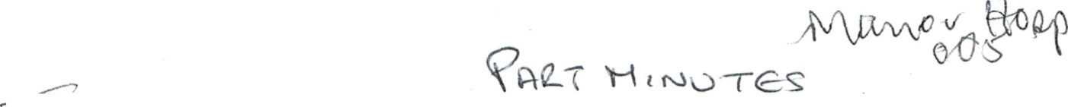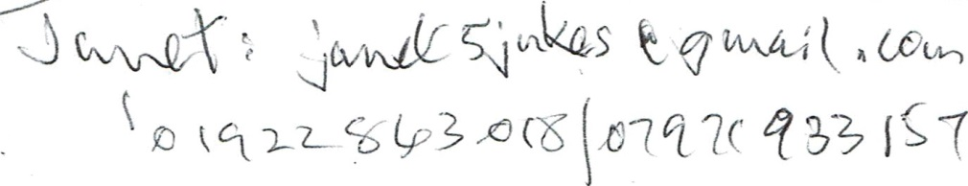

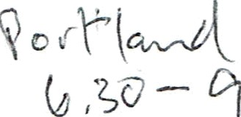
NORTHGATE PRACTICE PATIENT GROUP

NOTETAKER: Janet Jukes

MEMBERS PRESENT: Bob Ingram, Roger Corbett, Jo Worton,
Anne Harrison, Louise Platt, Dorothy Barrell,

APOLOGIES:

NEW MEMBERS:
Danny Newey, Maureen Nathaniel

Ian Gill

Welcome to all members who introduced themselves to the new members who also gave a brief reason of their interests.

No matters arising from minutes of last meeting

Chair update: SB explained that Dr Singal was forming a focus group on e-consultations which is a pilot promoted by the CCG. She said Dr Singal would like members to consider putting themselves forward so he could ‘try out’ first on members to trial who the e-consultation would be aiming for so that when it eventually goes live he will hopefully be ready for the surgery to be included. (Dr Singal arrived a little later and explained briefly how he would like it to work and said there would be a presentation so that members would know what would happen. He was pleased that quite a few members had signed the list seeking names of trial volunteers circulated during the meeting. Other members were considering joining the trial volunteers. He will keep us informed).

Update from Adam — by SB: Adam was unable to attend. SB quoted the following from his email:
- Pharmacy First: Both practices are set up but it is really more to do with the chemist than the practice. Receptionists should refer patients to the chemists. Any over the counter prescriptions can be had three times a year, without payment, at a Pharmacy but need to register first. For minor ailments patients should go to Pharmacy rather than 111 or 999.

- Carer’s state of health: Adam was asked at last meeting if the practice had a carers’ register, especially of young carers. He has replied, “The Primary care offer”. The surgery is awaiting certain information from the CCG but surgery has already started looking at it and the practice now has a Carers’ Chamption who is Debra Taylor. It was agreed to ask Debra if she can make our next meeting - if she has all the information available.

- Other news: Not much at the moment. The foyer has been tidied up and looks much more professional and welcoming. He is starting a clean-up of notice boards etc as there are far too many posters. By moving them from the walls it will not look so ‘paper heavy’.
- Northgate has had new LED lights throughout. These lights are more energy efficient. Also a new television has been installed with a few more presentations added. The ‘flu season is nearly here and he is working on the dates for programming injections. He says there may be a few Saturdays when the PG may be asked to help and he will inform SB or send an email to members. There is a new phlebotomy room being built in the Portland waiting area for Kath Millington. Both practices will use it and in time he hopes there will be a ‘take a ticket’ option. Adam will let us know when this happens.

SB raised the matter of possible changes to the Constitution and Terms of Reference, Possible revisions will be presented to a future meeting.

Patient Group Network: LP wasn’t able to go to the last meeting but hopefully will go to the next one and report back to the group.

AOB: DB asked what had happened to the extension to the surgery which was discussed at previous meetings. RC said it was not now going to happen yet. JW wanted us to do a survey about what patients wanted PG to do for them and any suggestions/complaints be put forward to the group. (JW and JJ will find out for next meeting)

BI tabled two documents for the meeting to consider – see attached. The first ‘Initial Thoughts Regarding Proposals for a Patient Profile’ was a follow-up to a positive discussion at the last meeting. The meeting endorsed the proposals in principle and it was agreed SB and BI would pursue further the paper’s proposals

BI’s second document ‘Thoughts Concerning An Initial Protocol for Formalizing a Closer Relationship with Practice Clinicians’ was intended to address the important implications of the contractual obligations for clinicians to have a more defined responsibility for the PRG and are required to work much more closely with its Practice PRG. The recent joint work (clinicians and PRG members) relating to dementia care was cited as an example of beneficial effort. It was agreed to return to this item at the next meeting.

Next Meeting Tuesday 22nd October at 5.0pm

